**Python Project for Economic Dispatch**

**Documented by: Bharath Kumar Thotakura 30th April 2025**

**_________________________________________________________________________________  
  
Background & Execution steps:**

1. Solution Overview

A Python-based economic dispatch optimizer that:

✔ Minimizes generation costs while meeting demand

✔ Handles regional power transfers with import/export limits

✔ Provides clear visual outputs with curtailment analysis

2. Execution Steps:

Setup

Folder Structure

Folder_Path/

├── data/

│ ├── Gen.xlsx

│ ├── Demand.xlsx

│ └── Region.xlsx

├── outputs/

├── ed_input.py

├── ed_calculation.py

├── ed_output.py

└── Economic_Dispatch.ipynb  
  
***Please add right path before executing the code***

3. Prepare Input Files

Separate module is prepared in .Py as below and prepare the input data for

File 1: Gen.xlsx

| Generator | Max Capacity | Region | Price ($/MWh) |
| --- | --- | --- | --- |
| Gen1 | 150 | North | 20 |

File 2: Demand.xlsx

| Hour | North | South | East |
| --- | --- | --- | --- |
| 1 | 250 | 400 | 150 |

File 3: Region.xlsx

| Region | Import Limit | Export Limit |
| --- | --- | --- |
| North | 50 | 100 |

Please find the below file formats as follows for input module preparation:

Input data module is give below and please prepare with proper path as per your file location.  
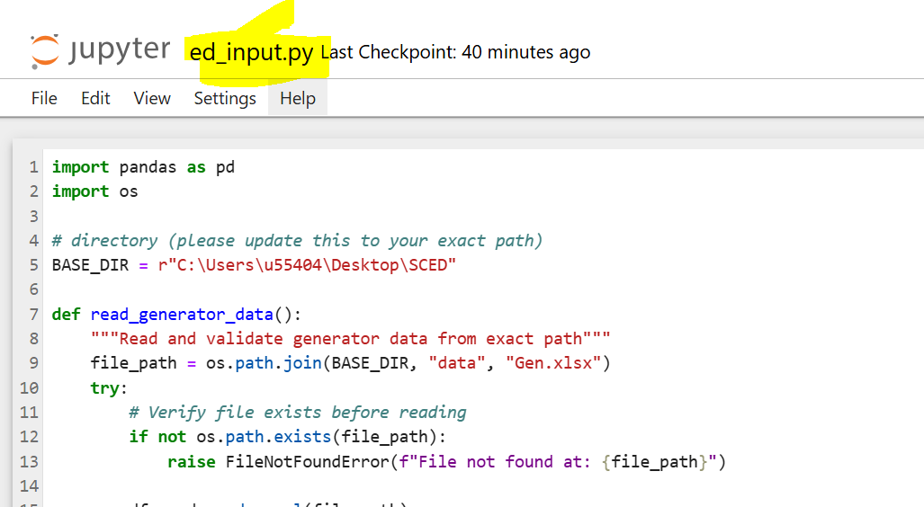

Module 2 is designed to execute the economic dispatch as below:  
  
Next modeule is output and it will allow to save the file in propert format with generation details with curtailment etc.   
  
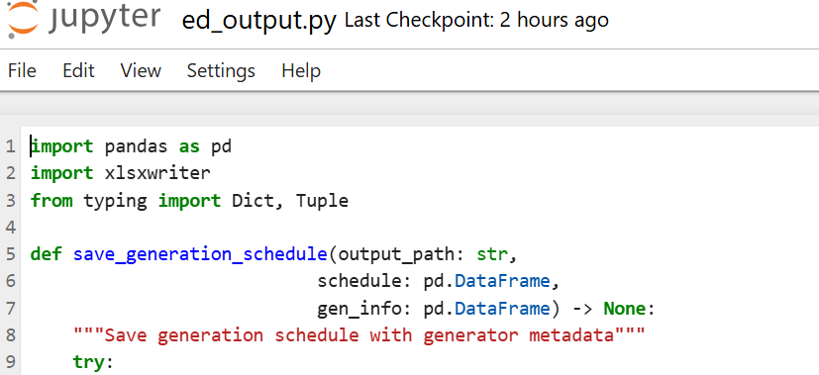  
  
Once the modules are ready then execute the execute cells in ***Economic_Dispatch.ipynb*** sequentially.

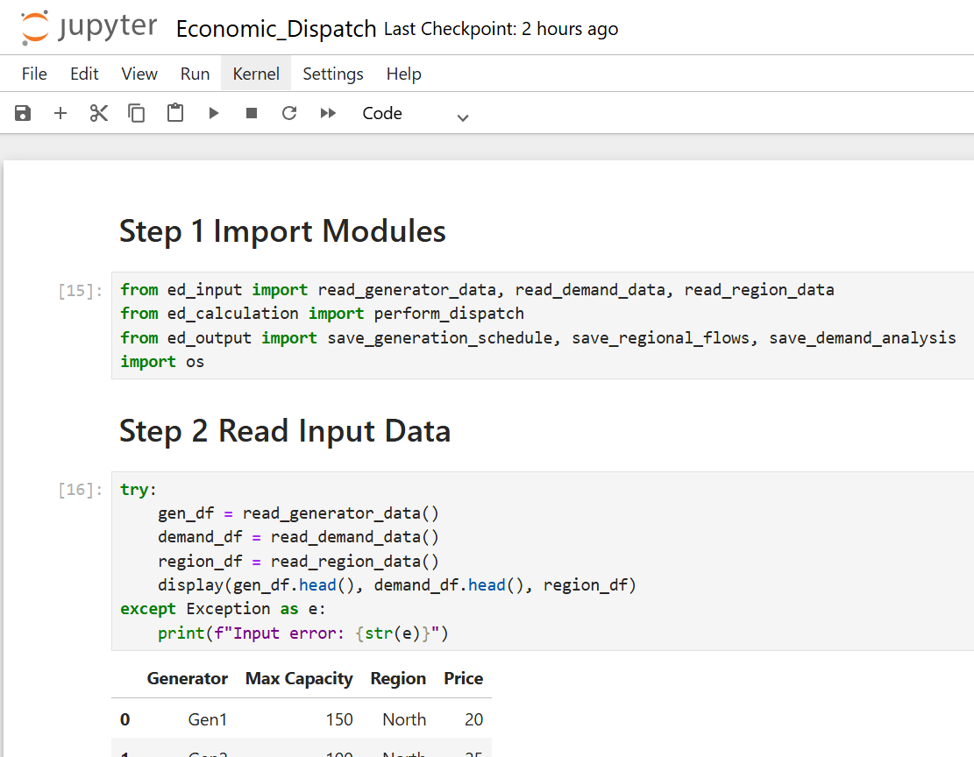

Each step will display on the status of completion and allow to save the output in proper understandable format of demand met with import/export details along with infeasible reason for each hour and also, highlighted as follows.

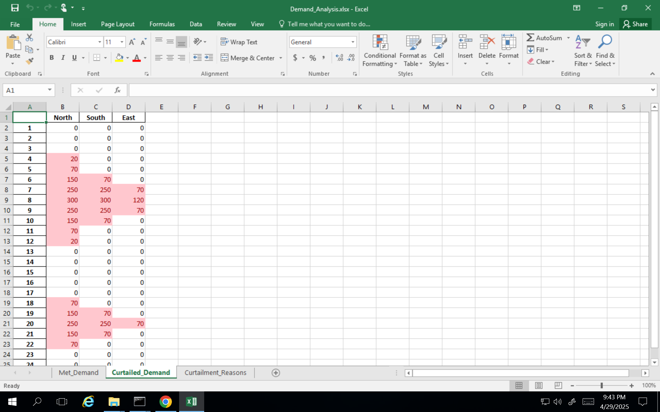   
  
***File Summary:***

|  |  |
| --- | --- |
| File | Remarks |
| Python Project for Economic Dispatch - Steps & Guide for execution | Helps to execute the code |
| Demand.xlsx | Demand data on hourly |
| Gen.xlsx | Generator details with capacity limits |
| Region.xlsx | Regional details with ATC limits |
| ed_calculation.py | Caculation moduel for ED problem |
| ed_output.py | Module to handle the output |
| ed_input.py | Module to handle the input data |
| Economic_Dispatch.ipynb | Final Notebook to run the code |
| Demand Analysis.xlxs | Demand usage detais |
| Generation_Schedule.xlxs | Details of generation |
| Regional_Flows.xlxs | Regional flow data (+ for import and – for export) |